ERIKA PATRICIA R. LINDIO BSIT301

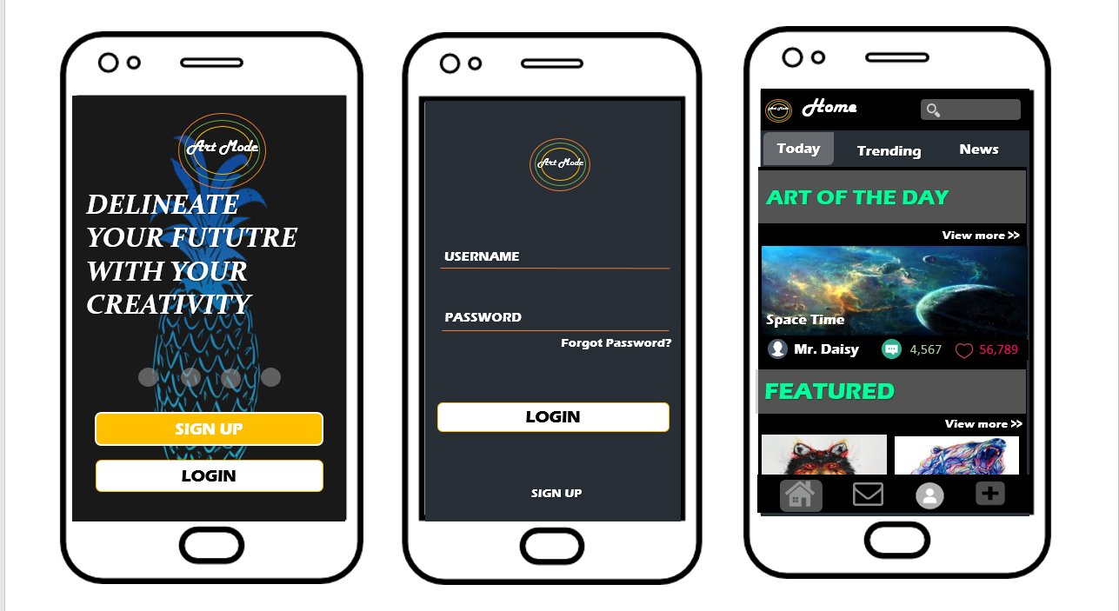

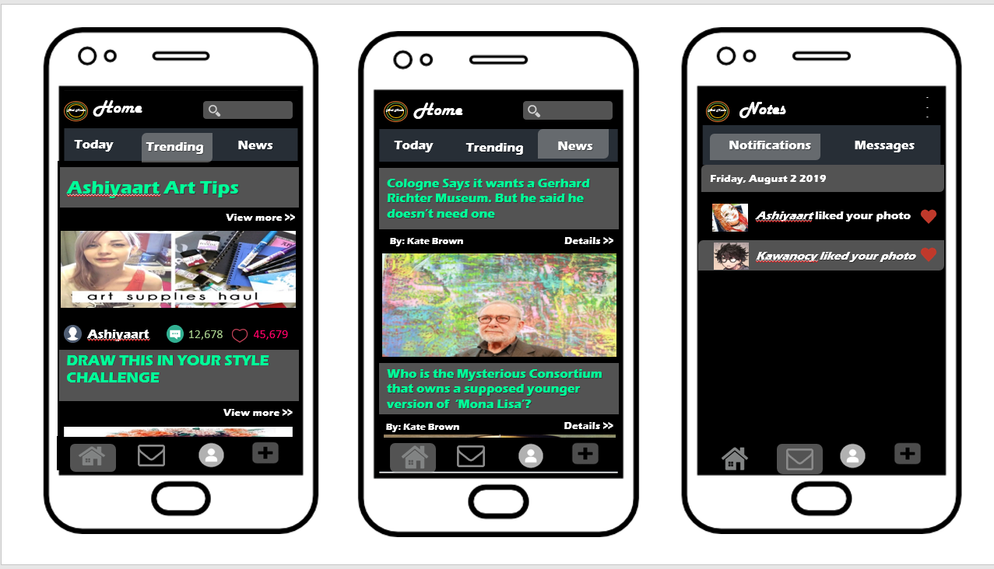

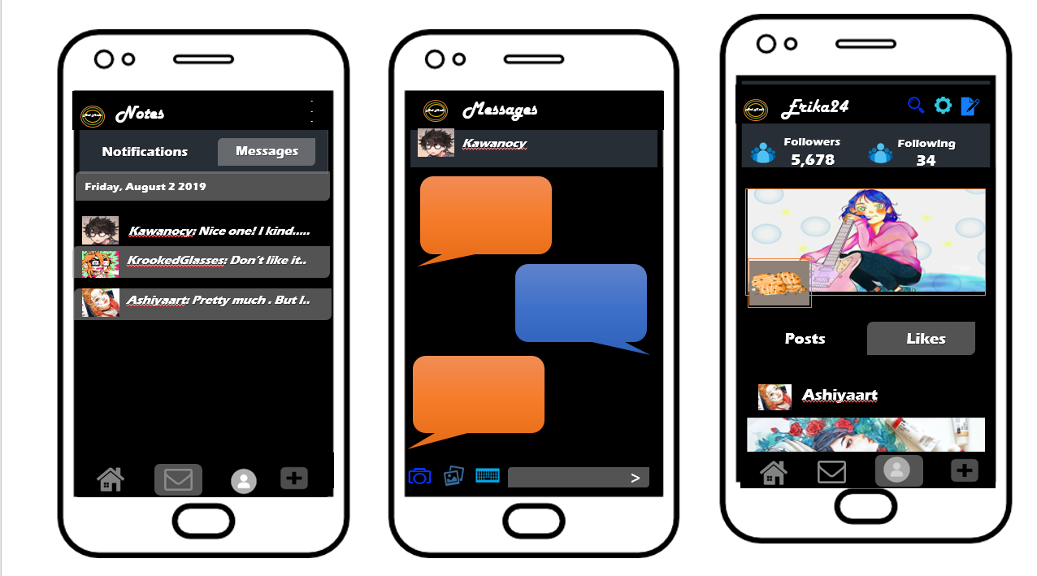

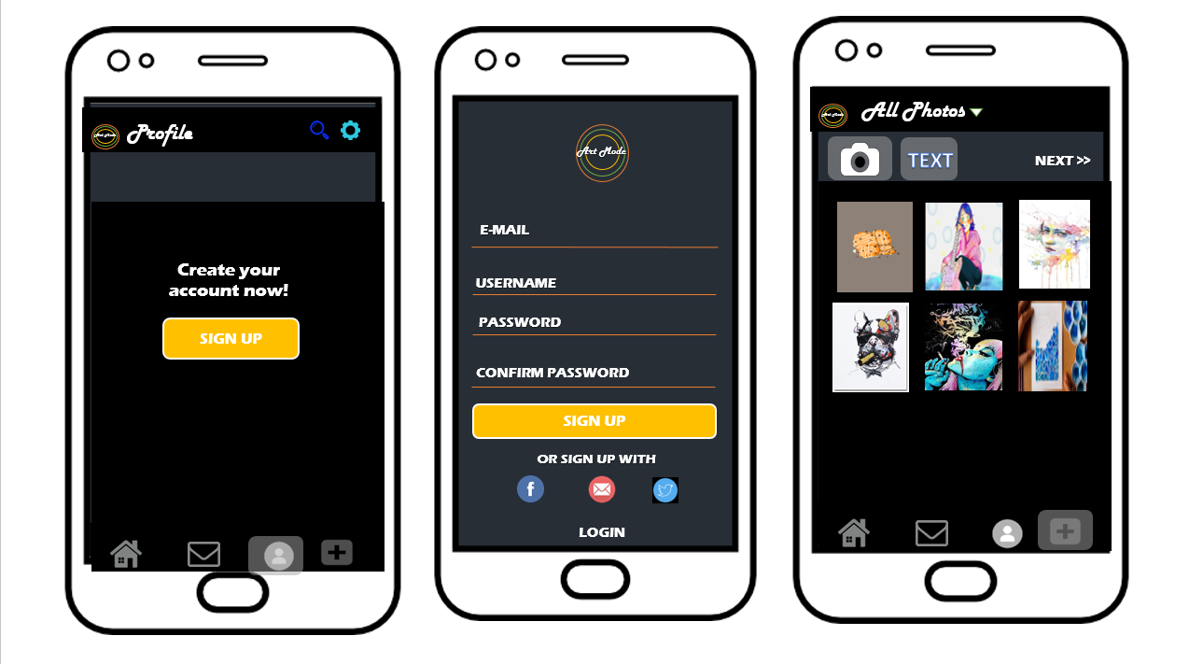

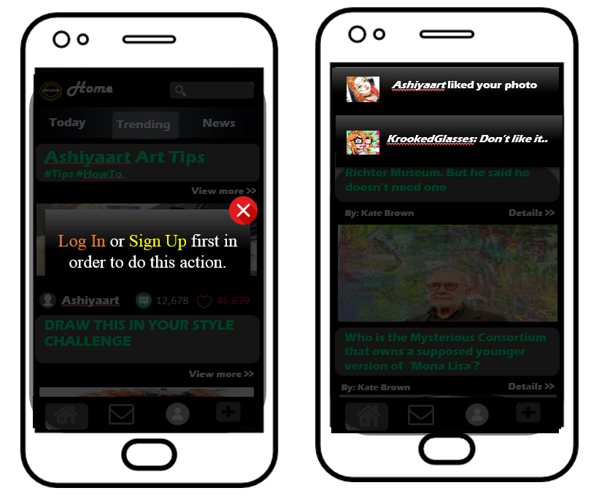

Users can explore the application even though they are not members nor part of it, but if they try to post, like or chat it will dim and a pop up will appear and remind them that they need to sign up first in order to do that and if they click the profile button and still not a member they will see a text and a button to create an account.

If the user is a member or already log in to the application their notifications that will appear if someone like, comment, or a latest news come up.

Art Mode is an application made for the people who wants to showcase their artistic self to the world. This application is not only for showcasing artistic works but also to show to the users the trends, the latest news about art world and more stuffs related to art. Users also can communicate with other users so that they can share information’s and do collaborations with them.

This application is not for all ages (only for 18+ and above) because there are some art works, news articles that are not for children, that they may not understand.

For the design I used other applications such as deviant art and tumblr as my guidelines, the color palettes they’ve used are not painful to the eyes but pleasing, I do change some of the colors and some arrangement in order to avoid copyright. As you can see I keep trying to make it look consistent and I don’t add too much button so that the users won’t get confused.

PRINCIPLES